**TASK 1**

**Create an interactive navigation menu that changes color or style when scrolled or when hovering over a menu item. The navigation menu should have a fixed position and be visible on all pages. Use HTML to structure the menu, CSS to style it, and JavaScript to add interactivity, such as changing the background color or font color of the menu when it is scrolled or when a menu item is hovered over.**

**CODE:-**

<!DOCTYPE html>

<html lang="en">

<head>

<meta charset="UTF-8" />

<meta name="viewport" content="width=device-width, initial-scale=1.0"/>

<title>Interactive Navigation Menu</title>

<style>

/* Basic Reset */

* {

margin: 0;

padding: 0;

box-sizing: border-box;

}

body {

font-family: Arial, sans-serif;

line-height: 1.6;

min-height: 2000px; /* To allow scrolling */

}

/* Navigation Bar */

nav {

position: fixed;

top: 0;

width: 100%;

background-color: transparent;

padding: 1rem 2rem;

display: flex;

justify-content: space-between;

align-items: center;

transition: background-color 0.3s ease, box-shadow 0.3s ease;

z-index: 1000;

}

nav.scrolled {

background-color: #333;

box-shadow: 0 2px 5px rgba(0,0,0,0.3);

}

.logo {

font-size: 1.5rem;

color: #fff;

}

ul.nav-links {

list-style: none;

display: flex;

gap: 1.5rem;

}

ul.nav-links li a {

text-decoration: none;

color: white;

font-weight: 500;

transition: color 0.3s, transform 0.2s;

}

ul.nav-links li a:hover {

color: #00bcd4;

transform: scale(1.05);

}

/* Add some page content to see scroll effect */

.content {

padding-top: 100px;

max-width: 800px;

margin: 0 auto;

padding-bottom: 2000px;

}

.content h1 {

margin-bottom: 20px;

}

</style>

</head>

<body>

<nav id="navbar">

<div class="logo">MySite</div>

<ul class="nav-links">

<li><a href="#">Home</a></li>

<li><a href="#">About</a></li>

<li><a href="#">Services</a></li>

<li><a href="#">Contact</a></li>

</ul>

</nav>

<div class="content">

<h1>Welcome to MySite</h1>

<p>Scroll down to see the navbar style change on scroll.</p>

</div>

<script>

const navbar = document.getElementById("navbar");

window.addEventListener("scroll", () => {

if (window.scrollY > 50) {

navbar.classList.add("scrolled");

} else {

navbar.classList.remove("scrolled");

}

});

</script>

</body>

</html>

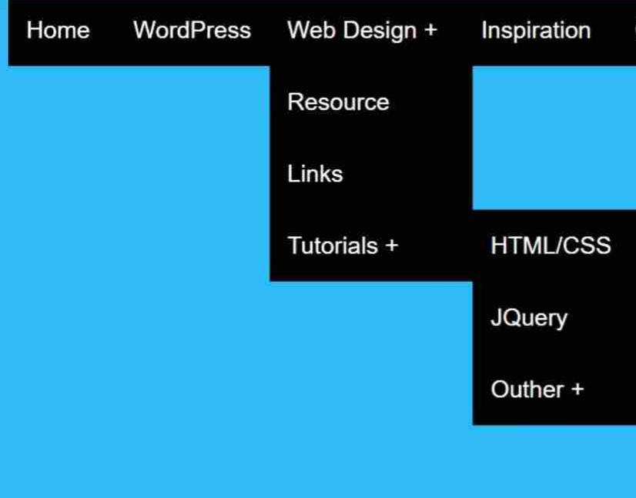**OUTPUT:-**